**  **

**TS -CAPSTONE PROJECT**

**Final report on**

**ENGLISH DICTIONARY**

**Full stack web development**

**Dr. B.R. Ambedkar university, Srikakulam**



Presented by:

B. Deepika(1981951059)

B. Visalakshi(1981951060)

P. joharika(1981951039)

Guided By:

Uma Maheswari

**Abstract:**

The English dictionary app consists of a search text field and a search button. The user has to enter the word in the text field and click on the search button. The result displays the word meaning ,word pronunciation audio clip. It also displays word usage for appropriate words.

**Index**

|  |  |  |
| --- | --- | --- |
| S.No | Table of contents | Page No |
| 1. | Introduction | 4 |
| 2. | Objective | 5 |
| 3. | Tools required | 6 |
| 4. | Benefits | 7 |
| 5. | Steps for English dictionary | 8 |
| 6. | Code | 11 |
| 7. | Conclusion | 12 |
| 8. | Reference | 13 |

**Introduction:**

A dictionary is used as a tool for referencing. It is used to look up meaning for a word or might also be used to look up the pronunciation of that word.

Nowadays there are a lot of dictionary being produced worldwide. These dictionaries could be found in all bookstores in various sizes.

Dictionaries on mobile devices are more practical then conventional dictionaries, as users can receive information quickly anywhere without space and time constraints.

This application built to help and meet the needs of the students to searching for meaning and understand various English words.

Objective:

This application is built to help & meet the needs of students, teachers or anyone across the word searching for meaning of words. It makes them understand various English words quickly & improve their language.

The dictionary software is developed to solve user’s vocabulary confusion or problem.

The main objective of this projects is to implement an English dictionary to find the meaning of words.

The English dictionary will user friendly so that any person with a basic knowledge access it.

Tools required:

The hyper text mark up language or html is the standard mark up language for documents designed to be displayed in a web browser. It is often assisted by technologies such as cascading style sheets (CSS) and scripting languages such as java script.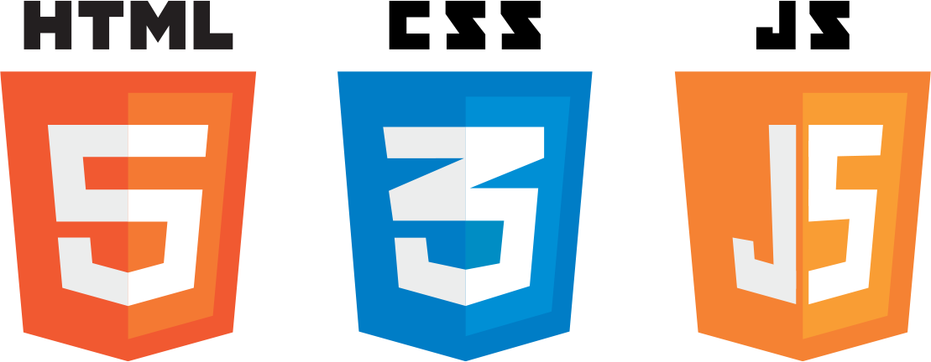

JavaScript (JS) is the most popular light weight, interpreted compiled programming language. It can be used for both client side as well as server-side development. JavaScript is also known as a scripting language for web pages.

Cascading style sheet language used for describing the presentation of a document written in a mark up language such as html or xml.

Benefits:

* Easy to find out the meaning of a word.
* Very and easy to handle for the user.
* To introduce a well GUI based interface.
* A good dictionary can help you understand your subject better, improve your communication and improve your grades.

Steps for english dictionary:

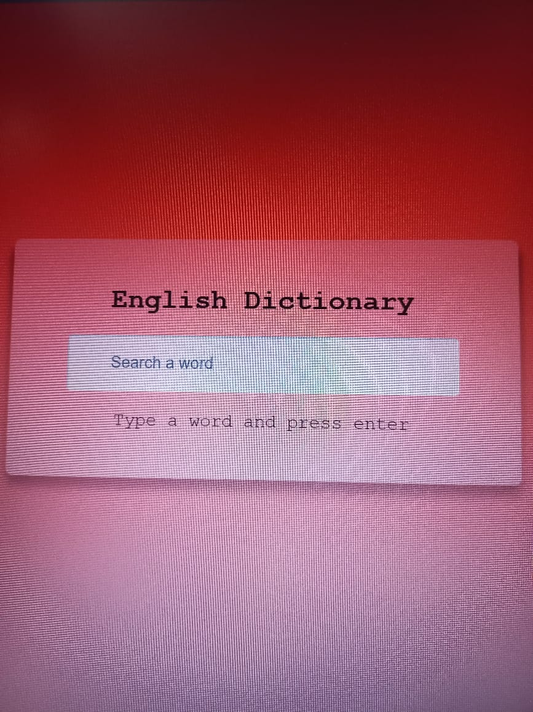

In English dictionary API , firstly type a word and press enter we can search any word in English in search box.

We have used the dictionary API to retrieve the definition of any term.

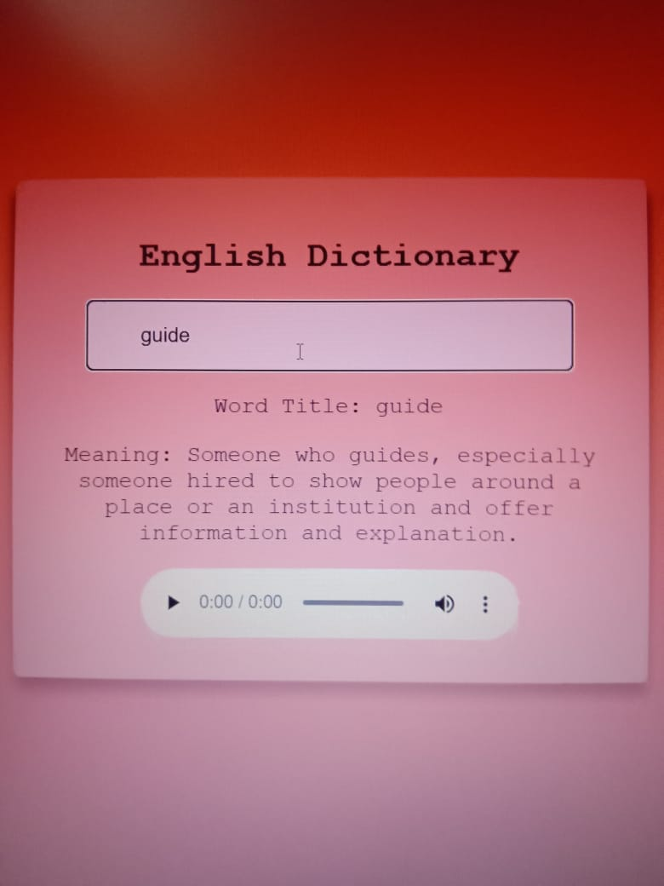

The meaning of the word is obtained and displayed on the website after the user presses the button, which attaches the word to the API URL.

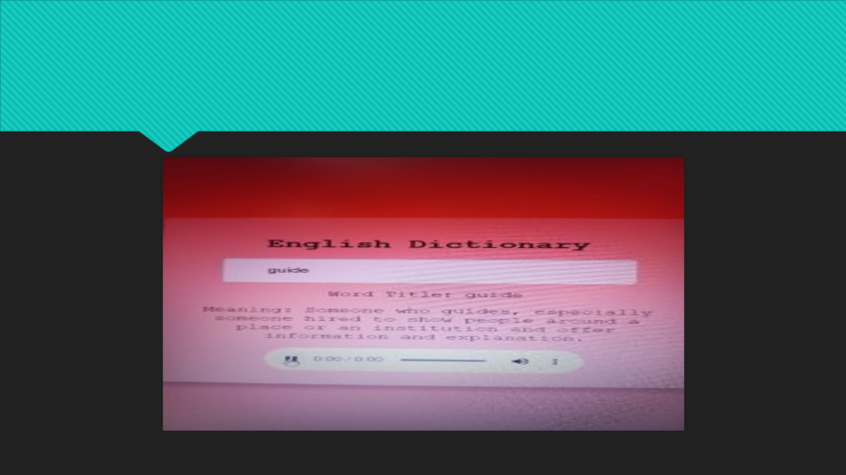

Code link:

https://github.com/Dee455/english-dictionary

conclusion:

The aim of the project is developed for the users who wants to know meaning of English words on users handle device.

Dictionary purpose a new idea for better experience. The proposed system helps to access English dictionary. The easy understandability and usability of the application makes it better .as the processing speed of the application is very fast it is head of all other dictionary application with its additional features.

Here we developed English dictionary which have almost all possible words in English. This project gives a new experience where the word easily detected by the application and gives the output very fast.

References:

<https://www.codingnepalweb.com/build-dictionary-app-html-javascript/>

<https://www.codewithrandom.com/2022/12/30/dictionary-app-using-javascript-dictionary-javascript-code-codewithrandom/>